***Assignment :1 Create an account in AWS and configure a budget.***

**Step 1:** Sign in to the AWS Management Console and click the corner profile button.

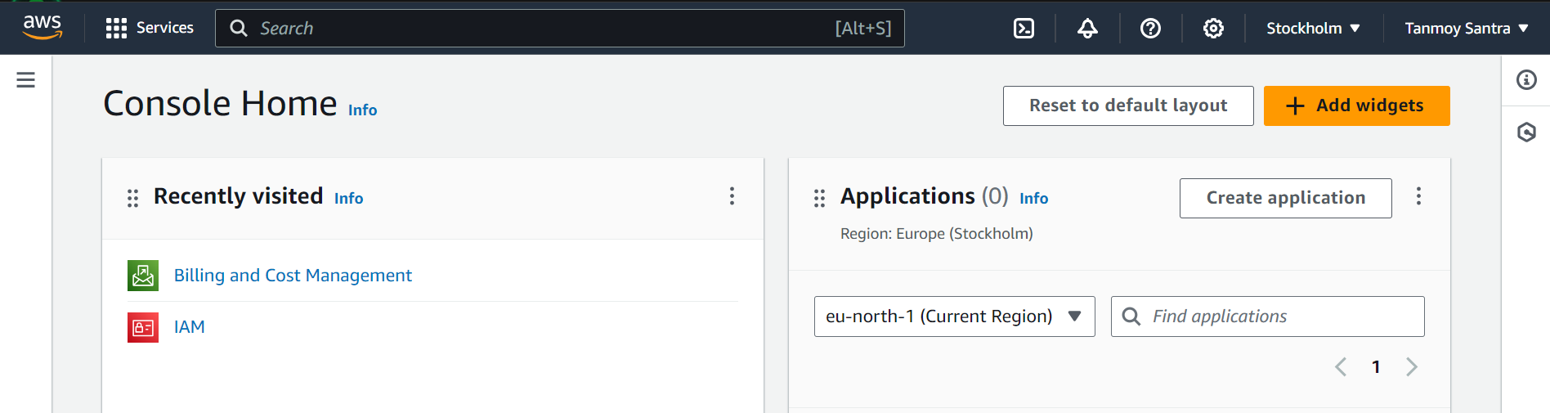

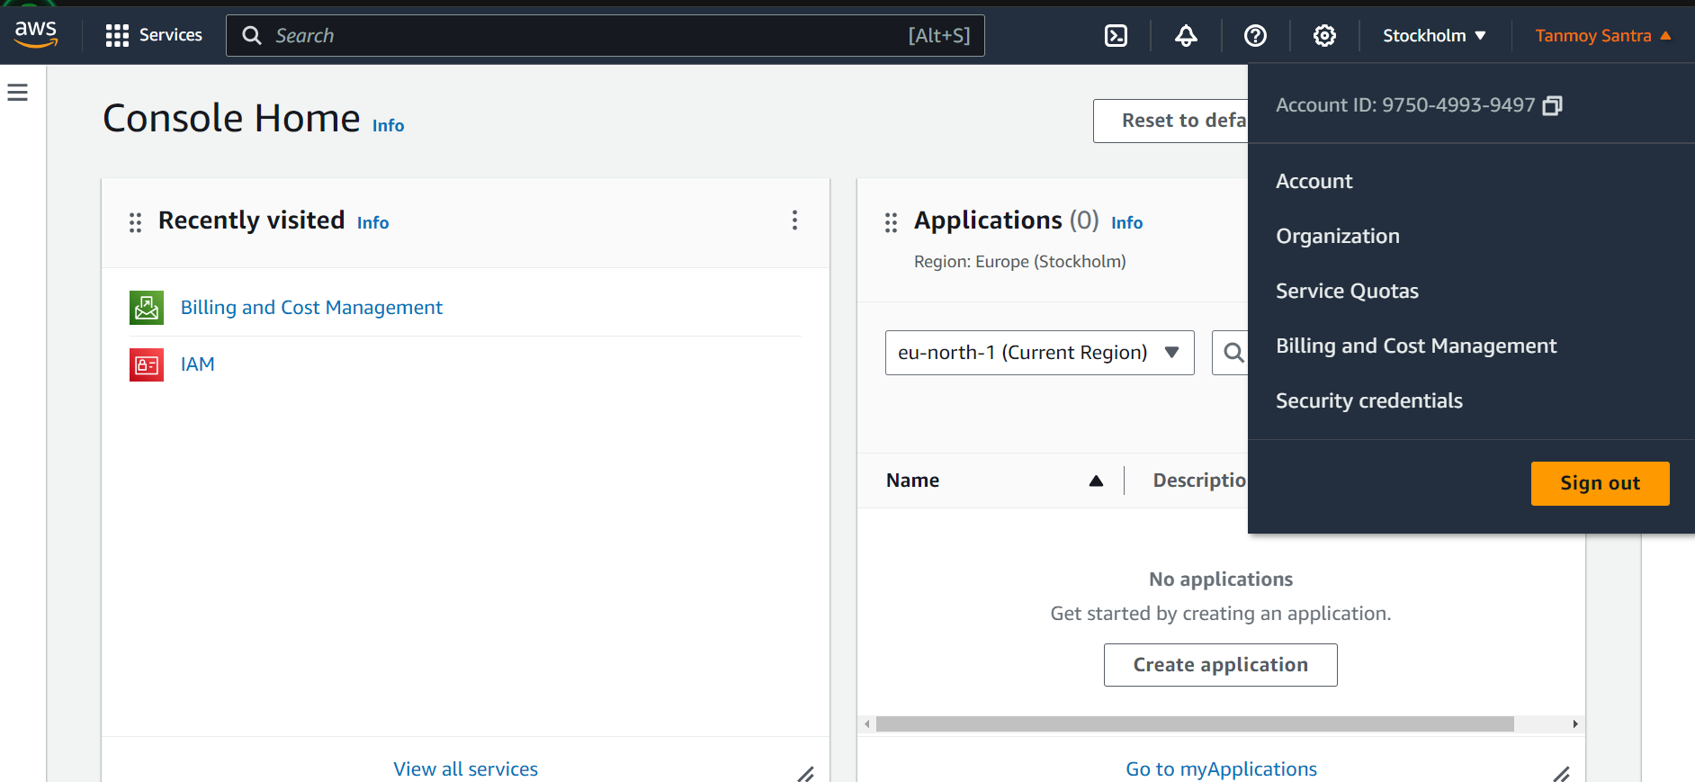step 2 : click Billing and Cost Management

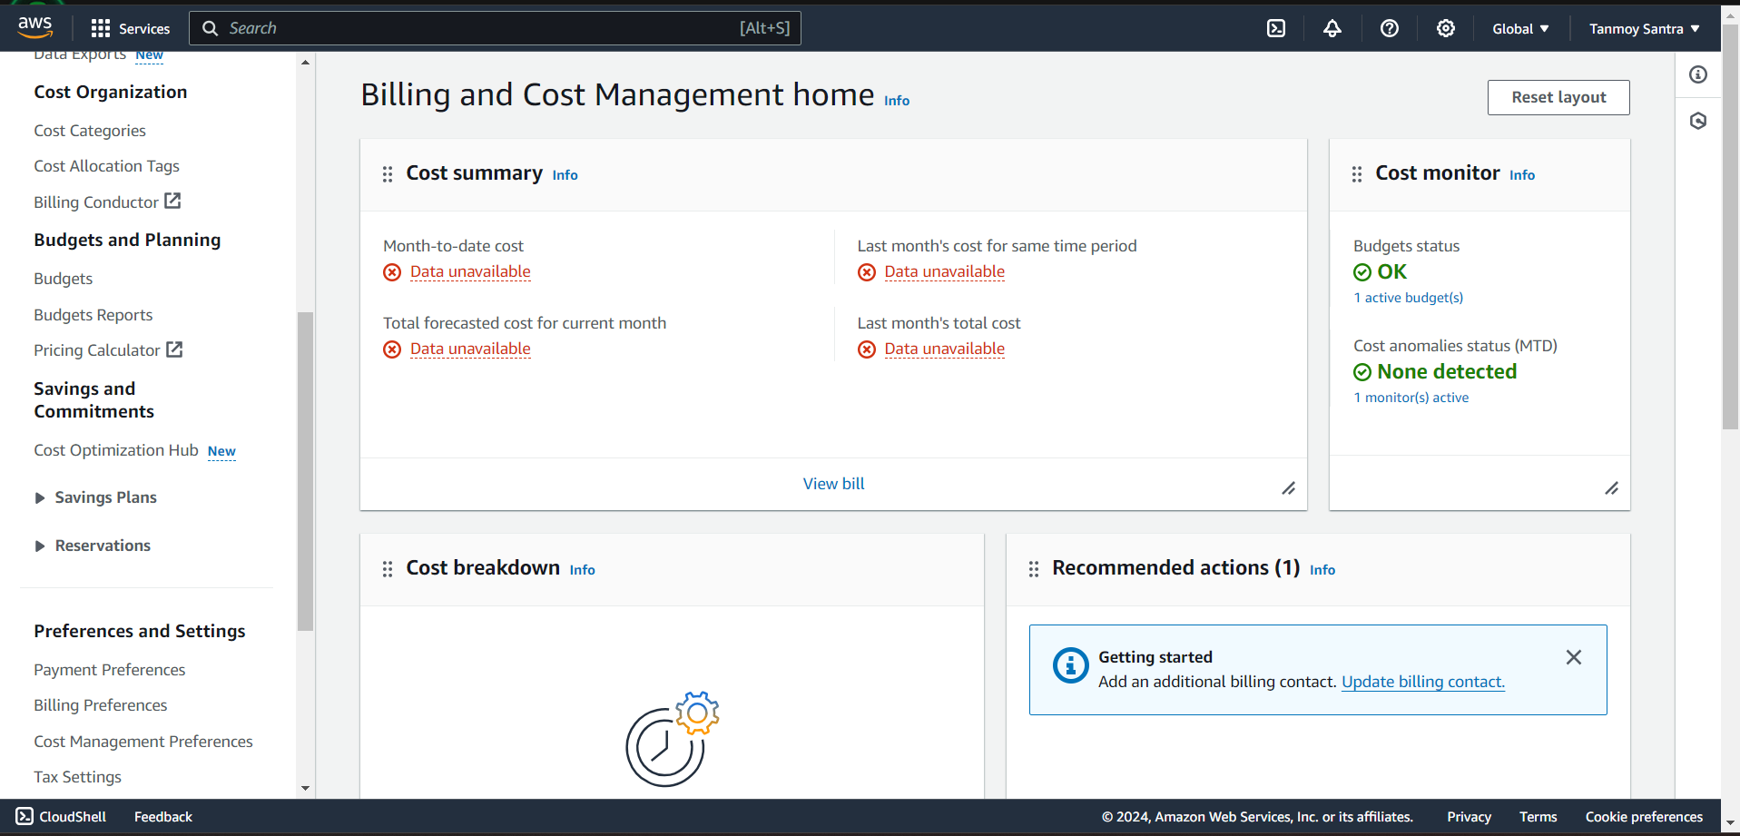 **Step 3:** In the navigation pane, choose **Budgets**.

**Step 4:** Press “create budget “

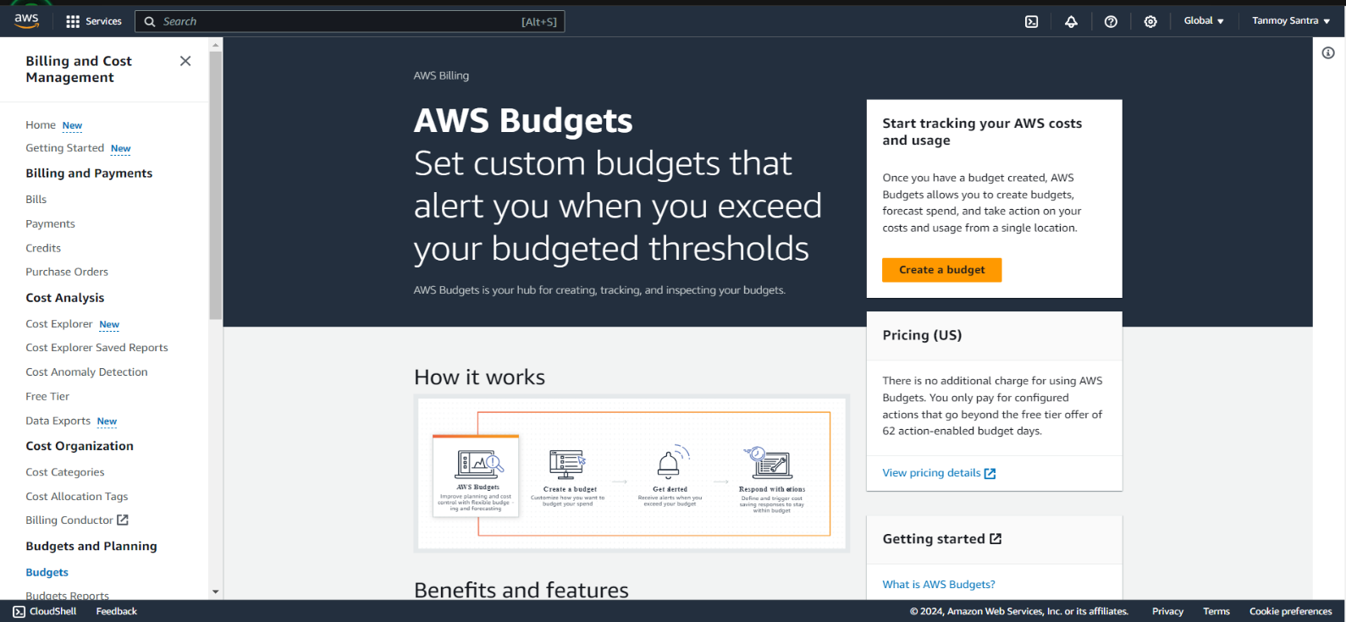

**Step 4:** Under **Budget setup**, choose **Customize (advanced) ,** Under **Budget types**, choose **Cost budget**. Then, choose **Next**.

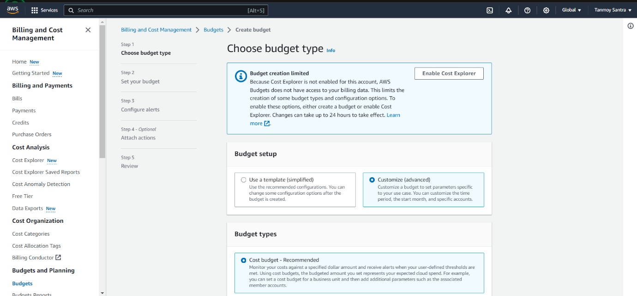Step 5: choose budget setup Customize (Advanced)

Step 6: click Next

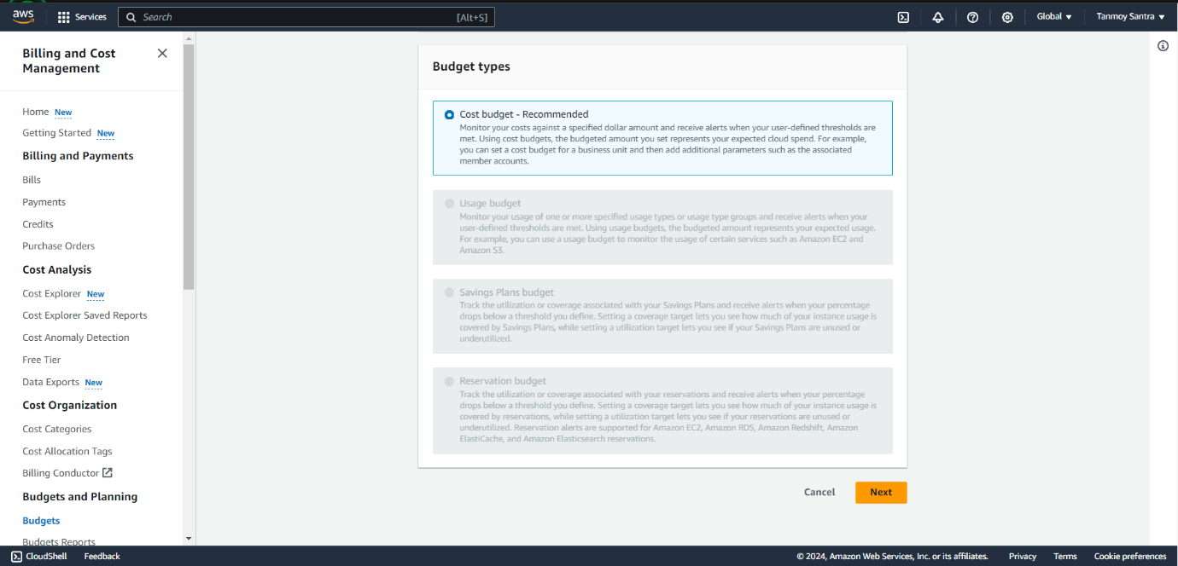

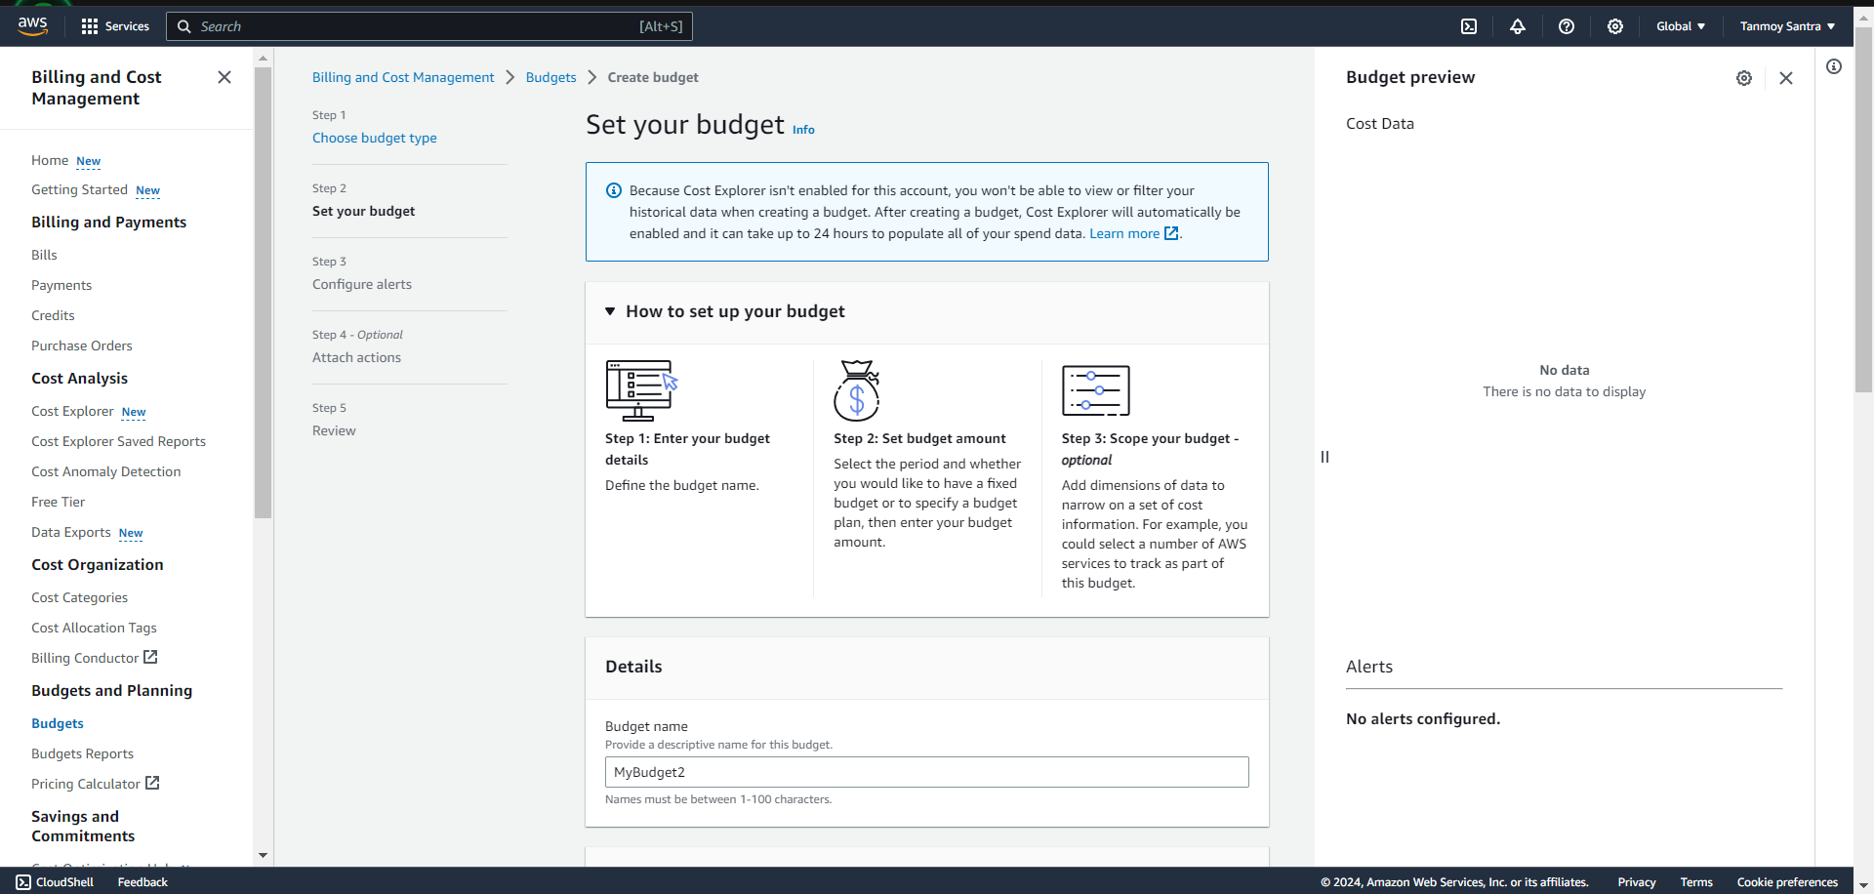**Step 7:** Under **Details**, for **Budget name**, enter the name of your budget. Your It can contain A-Z, a-z, spaces, and the following characters .In my account I set new budget name as “MyBudget2”.

**Step 8:** Under **Set budget amount**. Select **Daily** for every day, **Monthly** for every month, **Quarterly** for every three months, or **Annually** for every year. I choose **Monthly**.

For **Budget renewal type**, choose **Recurring budget** for a budget that resets after the budget period. Choose the start date or period to begin tracking against your budgeted amount. Then press Next.

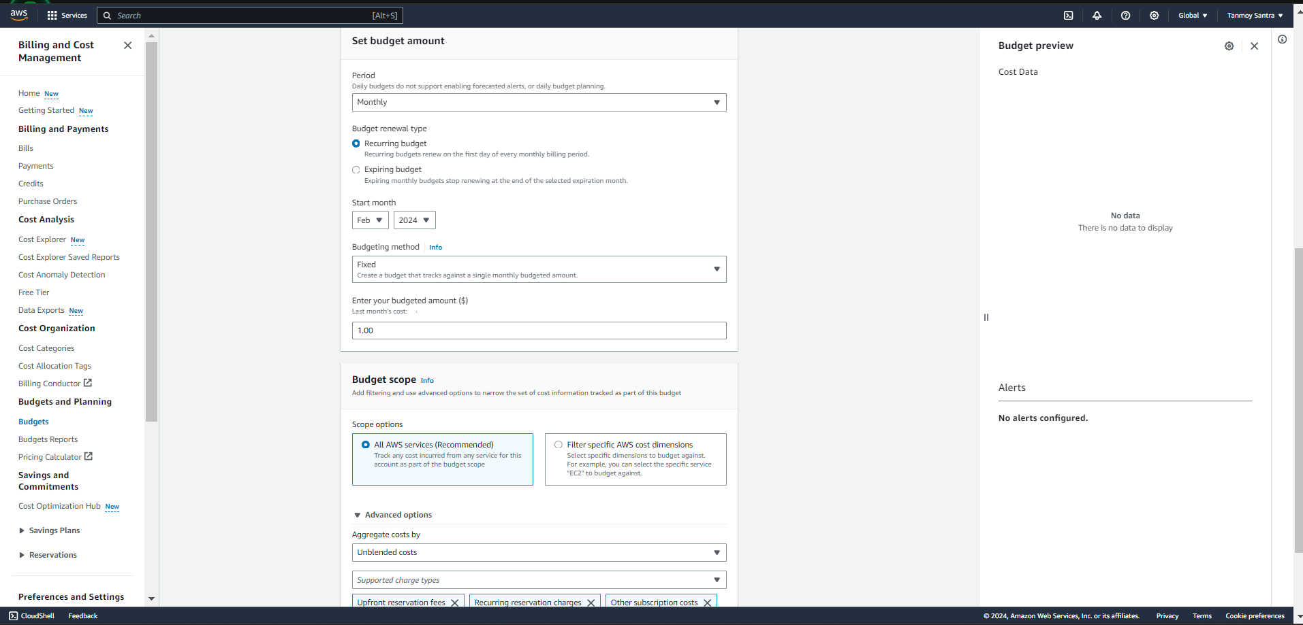

**Step 9:** Choose **Add an alert threshold**. Under **Set alert threshold**, for **Threshold**, enter the amount that must be reached for you to be notified. This can be either an absolute value or a percentage. Under **Notification preferences**, for **Email recipients**, enter the email addresses that you want the alert to notify. Choose **Next**.

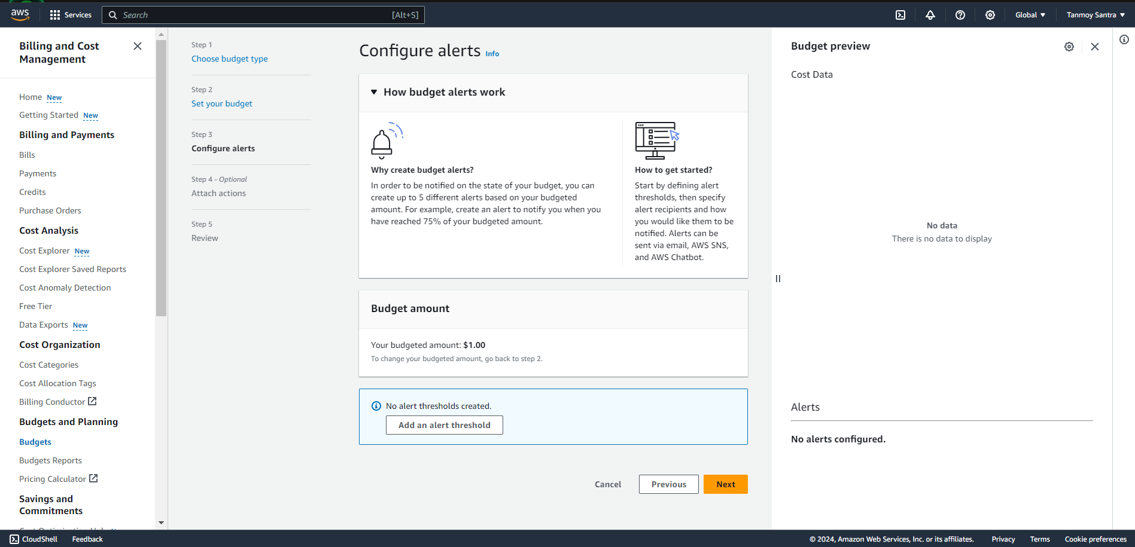

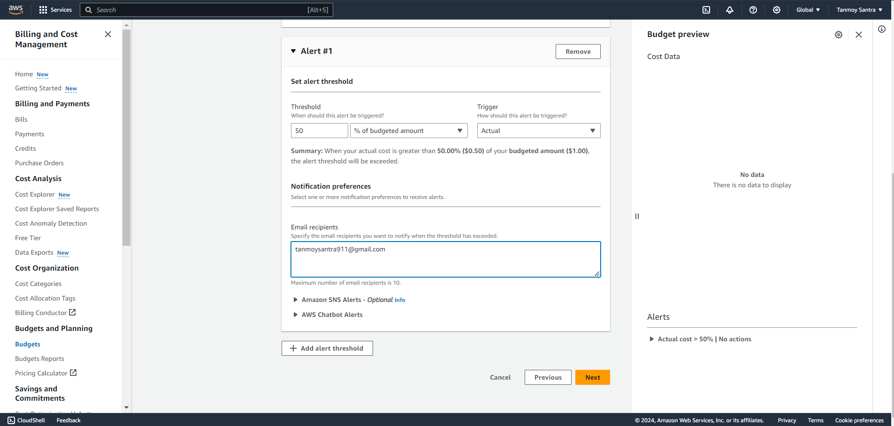

**Step 10**: Review your budget settings, and then click **Create budget**.

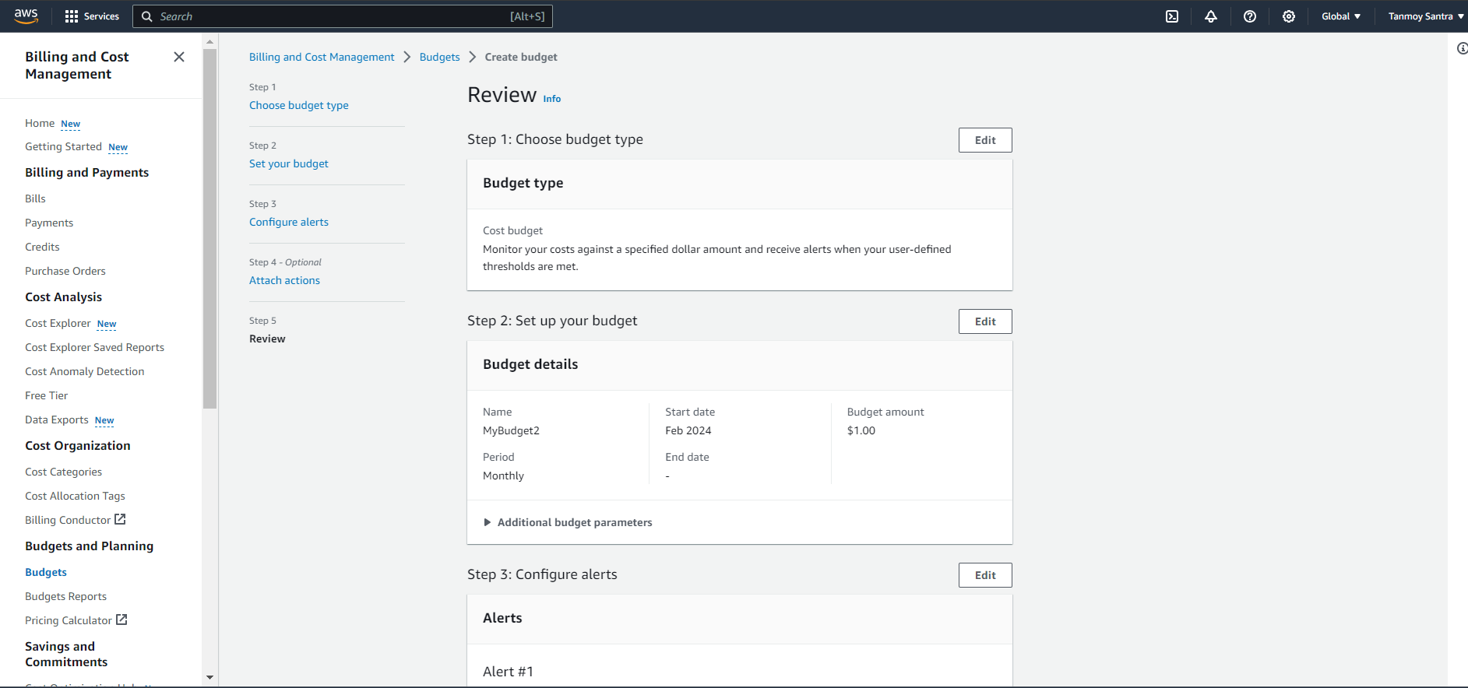

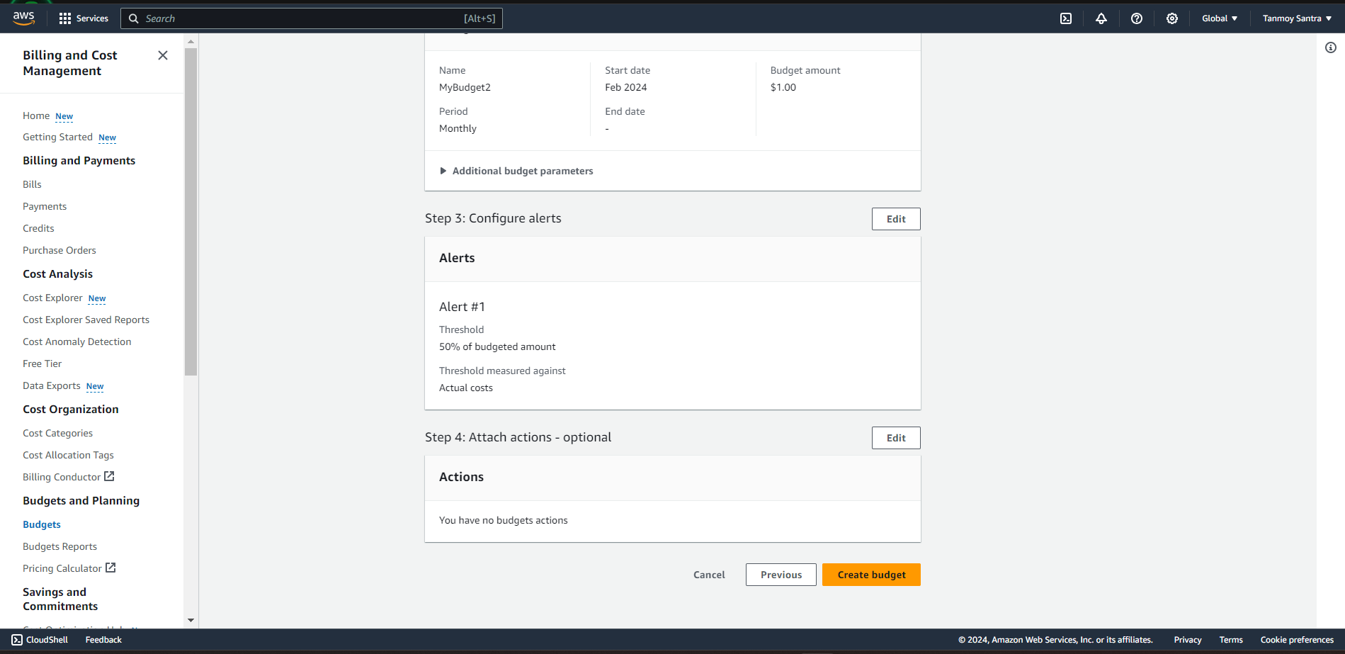

Now see new budget is created as “**MyBudget2**”

